**Capstone Project(Food Box)**

Sprint

**Sprint 1:** Creating a spring boot application, defining all the entity classes and creating REST API.

**Sprint 2:** Creating Angular Project and adding all the components.

**Sprint 3:** Integrating Jenkins and pushing source code to git hub.

**Sprint 4:** Adding all data to the database

Concepts & Algorithms used.

* Spring Boot
* Jenkins
* Angular
* HTML, CSS, BOOTSTRAP

GitHub Link FrontEND https://github.com/Akash19121997/frontend-ecommerse

GitHub Link backEND : https://github.com/Akash19121997/backend-ecommerse

**Project Flow**

Main Page

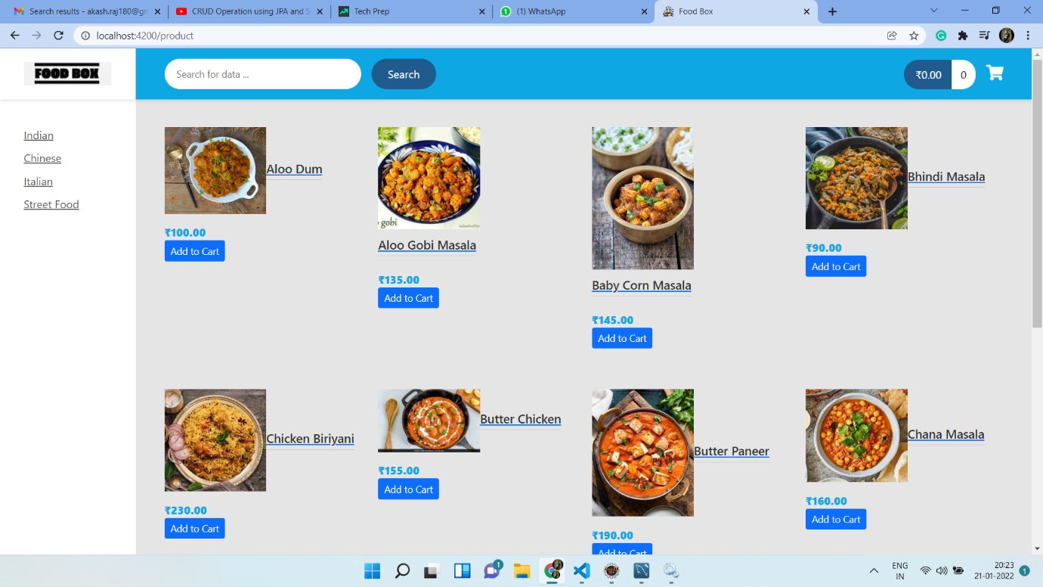

Add to CART

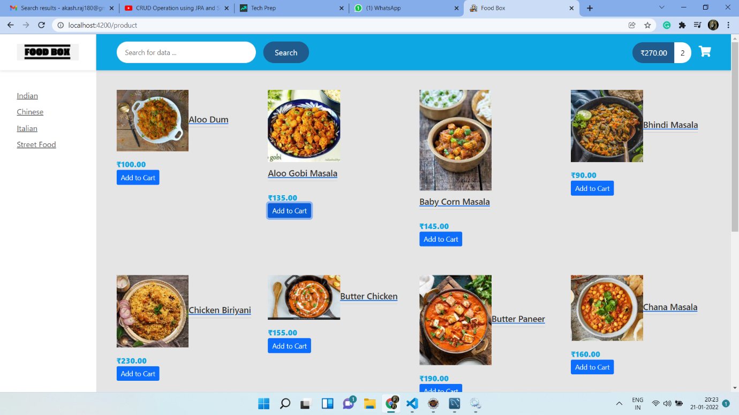

Detail Component

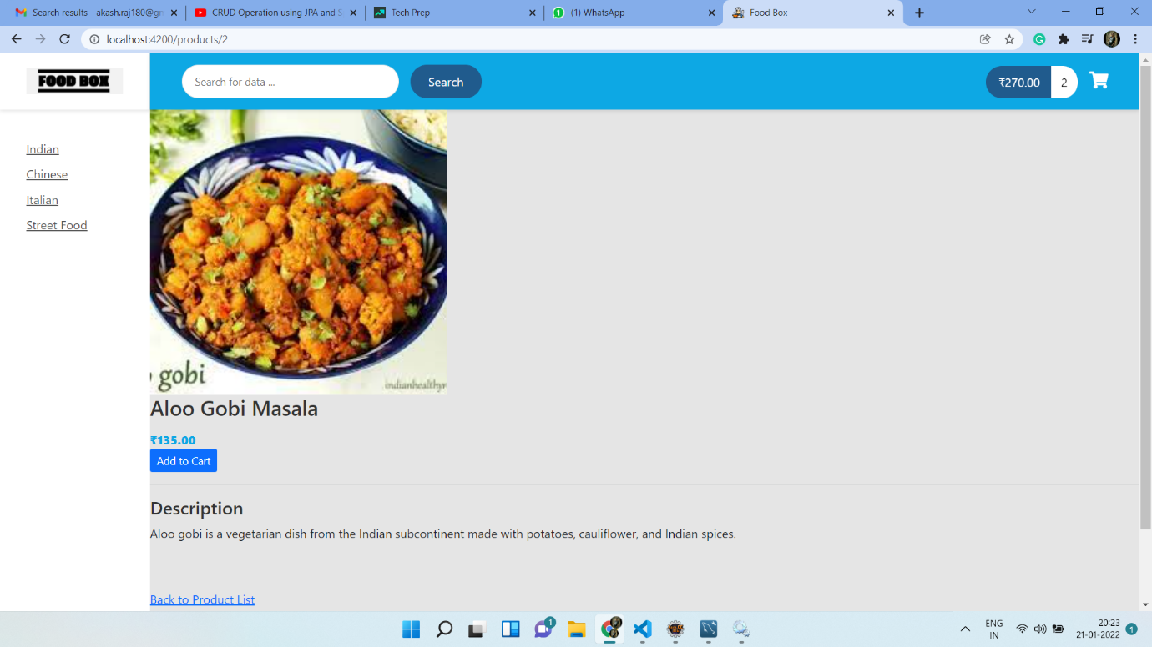

Cart

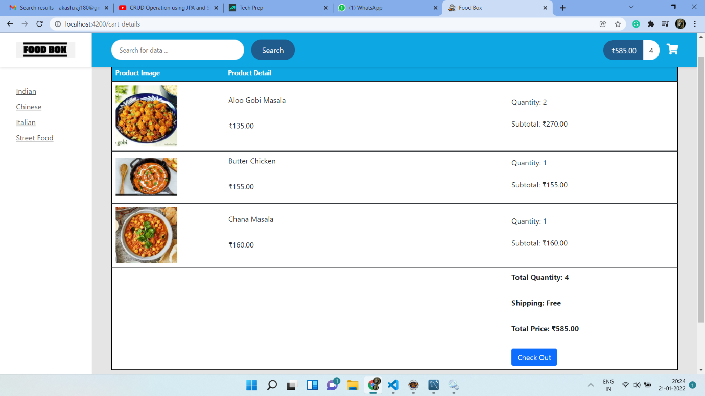

Order Done

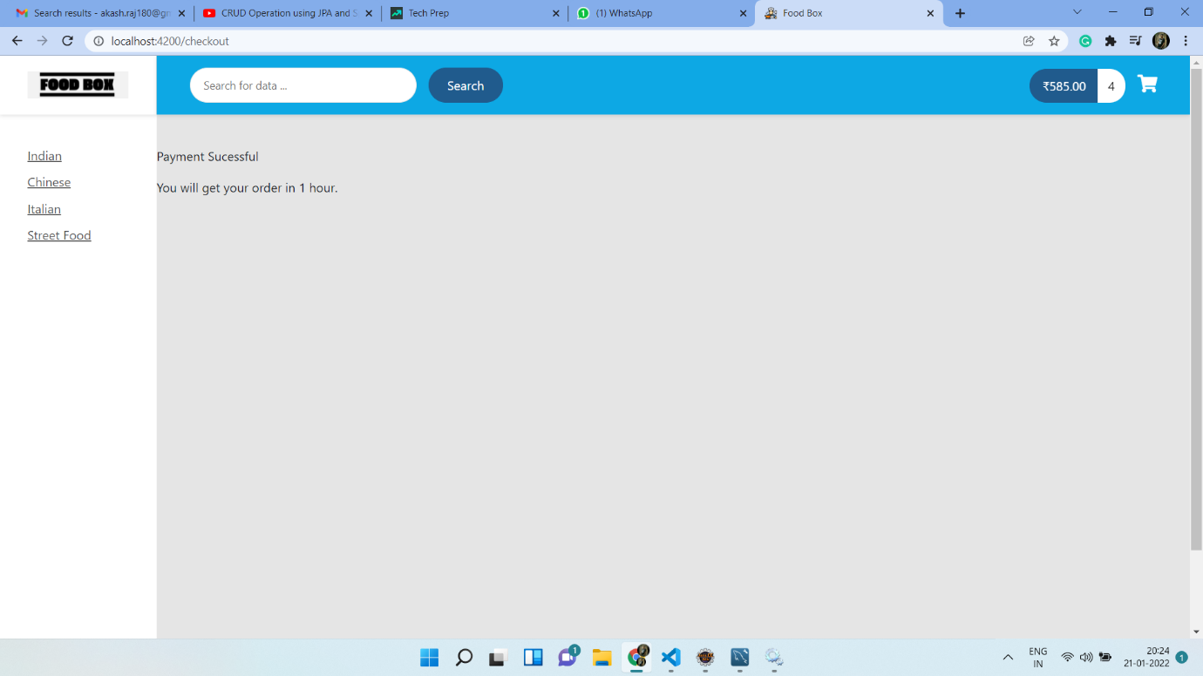

Search Component

